Project Design Phase-II
Data Flow Diagram & User Stories

Date | 31 January 2026
Team ID
Project Name | F1 Race Intelligence Dashboard & Analytics
Maximum Marks | 4 Marks

Data Flow Diagrams:
Data Flow Diagram Description
- External Entity: F1 Analyst / User (Strategist, Media Analyst, FIA Compliance Officer).
- Process 1 (Data Ingestion & Cleaning): Reads raw multi-sheet Excel file, validates fields, and maps dimensions/measures.
- Data Store D1: Raw F1 Dataset (F1 Racing Project Dataset.xlsx).
- Process 2 (Analytical Calculation & Aggregation): Computes KPIs (SUM(points), AVG(dnf), COUNTD(race_id), Race Completion Rate).
- Data Store D2: Tableau Processed Data Model / Extracted Data.
- Process 3 (Dashboard Visualization & Interaction): Renders the 9 charts across 3 scenario layout blocks and applies interactive cross-filtering.
- Output: Interactive F1 Race Intelligence Dashboard presented to the User.

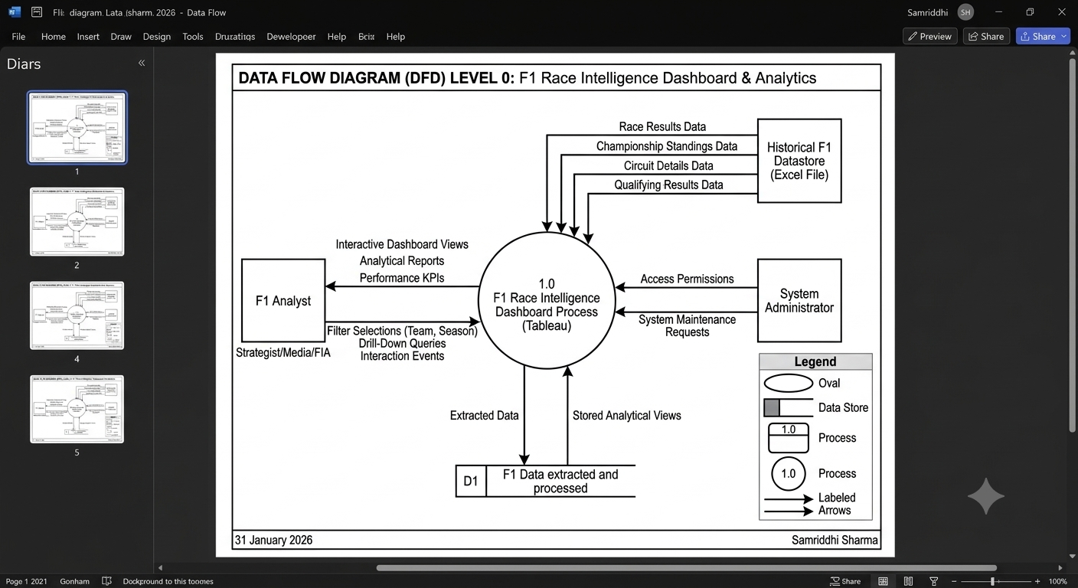

User Stories
Use the below template to list all the user stories for the product.
User Type | Functional Requirement (Epic) | User Story Number | User Story / Task | Acceptance criteria | Priority | Release
Team Performance Strategist | Authentication & Access | USN-1 | As a team performance strategist, I can access the analytical portal securely to view benchmark dashboards. | I can log in and view the primary team performance analytics workspace. | High | Sprint-1
 | Team Benchmark Analysis | USN-2 | As a team performance strategist, I want to compare championship point trajectories across seasons for top competitors and my team. | Interactive line chart displays historical points across 17 seasons for selected teams. | High | Sprint-1
 | Tyre Strategy Analysis | USN-3 | As a team performance strategist, I want to evaluate starting tyre compound performance across different circuit types. | Heatmap displays starting compound vs. circuit type showing AVG(points) with clear visual indicators. | High | Sprint-1
 | Talent Evaluation | USN-4 | As a team performance strategist, I want to identify top drivers ranked by total championship points to guide driver recruitment. | Horizontal bar chart ranks top drivers descending by total cumulative points. | Medium | Sprint-1
Motorsport Broadcast Analyst | Global Circuit Intelligence | USN-5 | As a motorsport broadcast analyst, I want to identify which countries have hosted the highest number of Grand Prix rounds. | Bar chart displays host countries ranked by distinct race counts (CNTD(race_id)). | High | Sprint-1
 | Driver Achievements | USN-6 | As a motorsport broadcast analyst, I want to retrieve total podium counts by driver for live broadcast infographics. | Horizontal bar chart displays total SUM(podiums) per driver sorted descending. | High | Sprint-1
 | Constructor Achievements | USN-7 | As a motorsport broadcast analyst, I want to compare podium finishes across all constructor teams for pre-race commentary. | Horizontal bar chart displays total SUM(podiums) aggregated by team. | Medium | Sprint-2
Technical Regulation Analyst | DNF Failure Diagnostics | USN-8 | As a technical regulation analyst, I want to identify common DNF failure types across constructor teams to evaluate mechanical issues. | Stacked bar chart shows DNF counts (dnf=1) broken down by failure reasons per team. | High | Sprint-2
 | Circuit Reliability Analysis | USN-9 | As a technical regulation analyst, I want to compare DNF rates across permanent, street, and street/park circuits. | Bar chart shows AVG(dnf) formatted as a percentage across circuit classifications. | High | Sprint-2
 | Regulatory Impact Tracking | USN-10 | As a technical regulation analyst, I want to track driver race completion rates over 17 seasons to evaluate technical rule changes. | Line chart plots 1 - AVG([dnf]) formatted as percentage over all recorded seasons. | High | Sprint-2
System Administrator | Data Refresh & Ingestion | USN-11 | As a system administrator, I can ingest and map new multi-sheet Excel data without breaking dashboard views. | Tableau data connectors update source tables cleanly while preserving calculated measures. | High | Sprint-1
 | Interactive Layout & Filtering | USN-12 | As a system administrator, I can provide cross-filtering so clicking a team or season updates all 9 dashboard charts dynamically. | Global dashboard filters and "Use as Filter" actions operate across all worksheets in <2 seconds. | High | Sprint-2

